Andrew Abbott

MSDS 7346

Mini-Project 2

September 25, 2017

Step 1: Sign up for a MongoDB Atlas Account

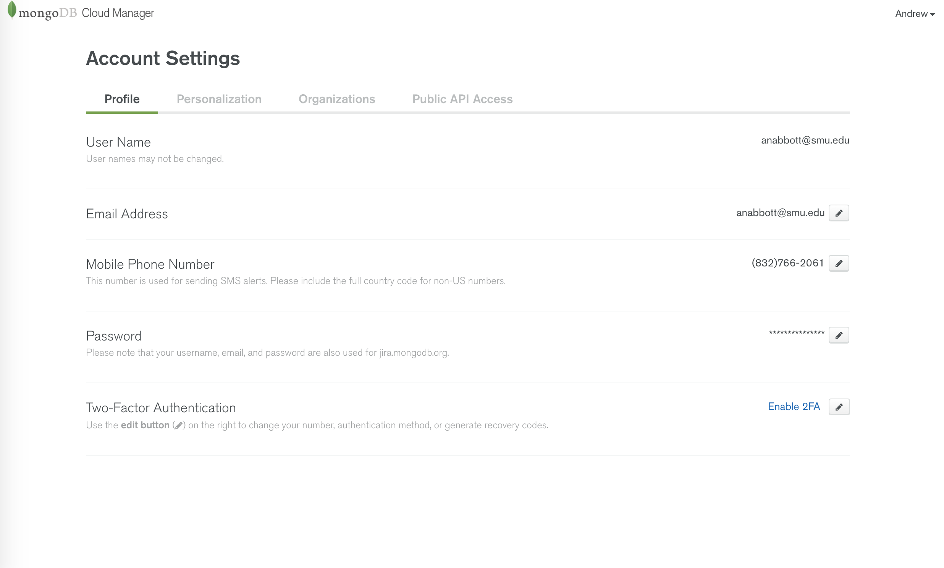

Step 2: Create a cluster in MongoDB Atlas

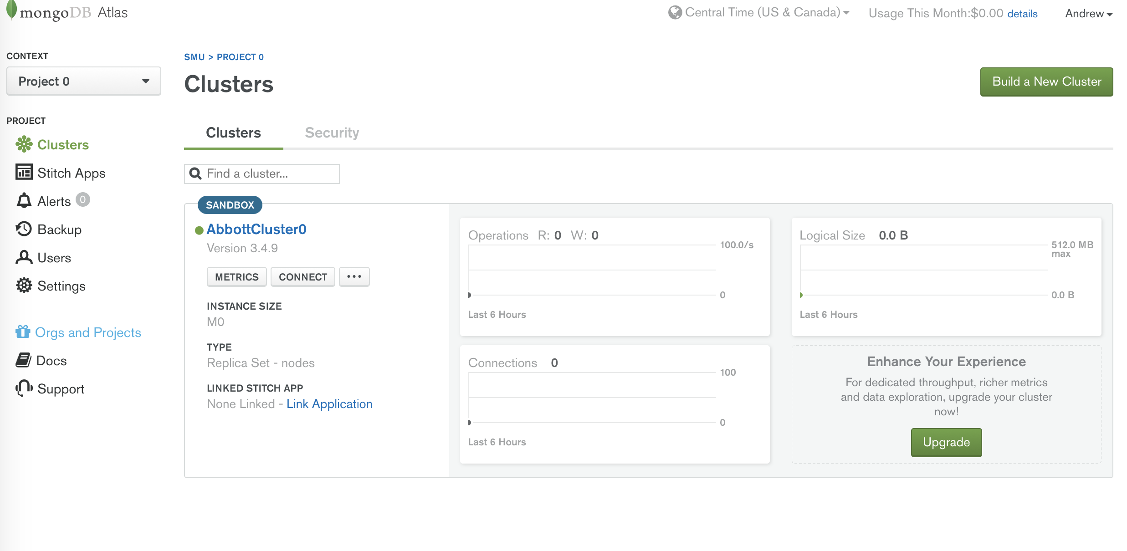

Step 3: Download MongoDB Compass

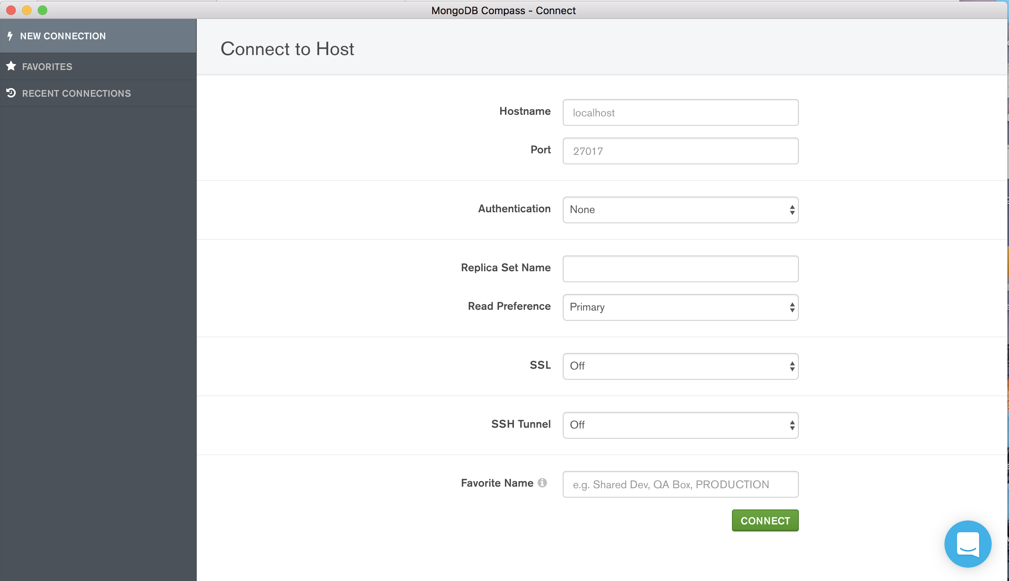

Step 4: Connect MongoDB Compass to Atlas’s cluster

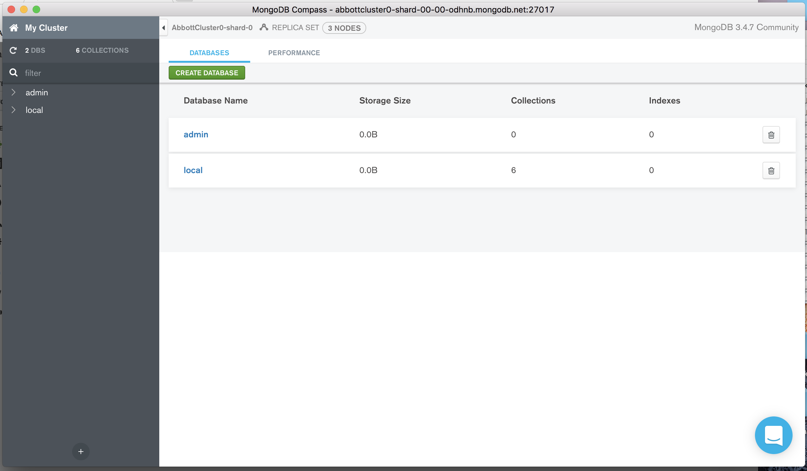

Step 5: Experiment with Compass as stated

Using mongoimport to import the postcode.csv file to Atlas:

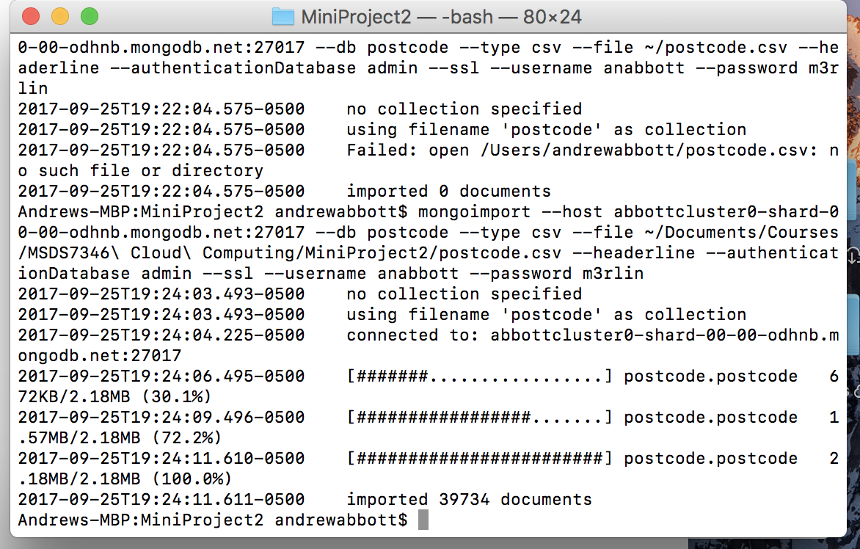

Verify the import:

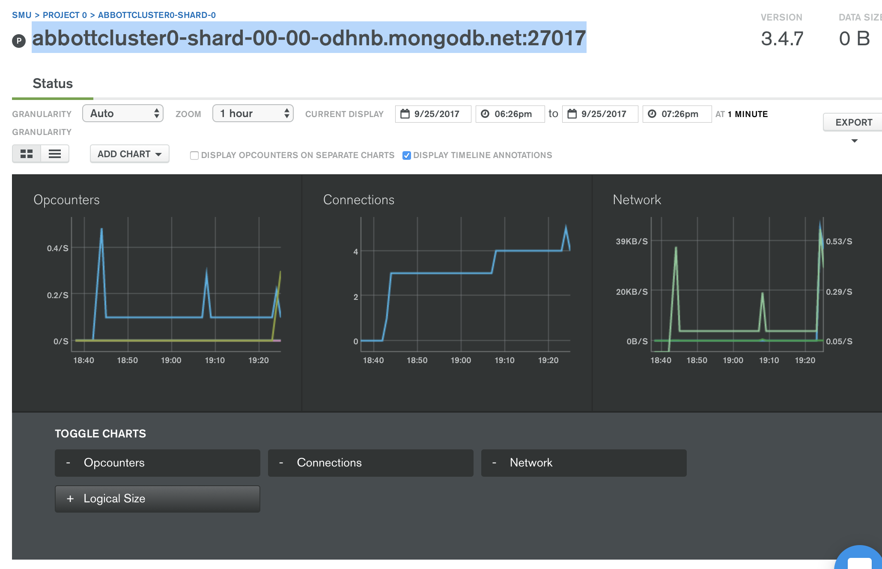

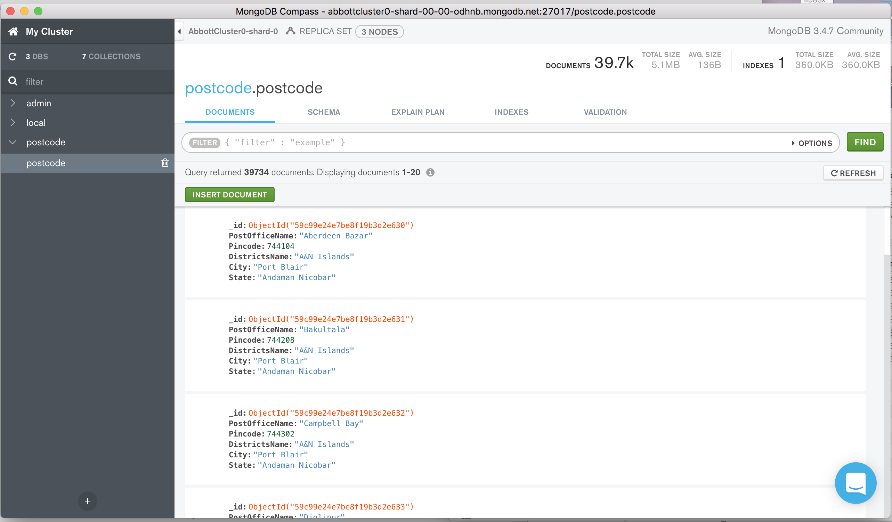

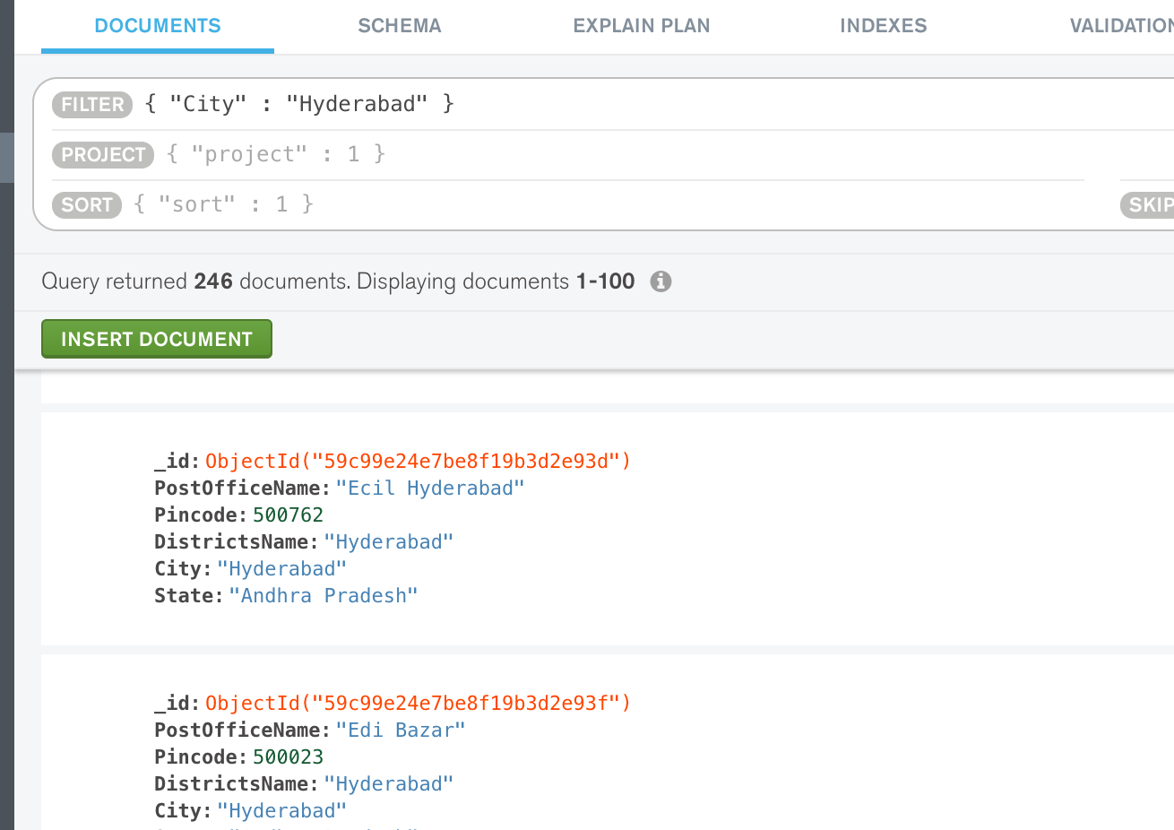

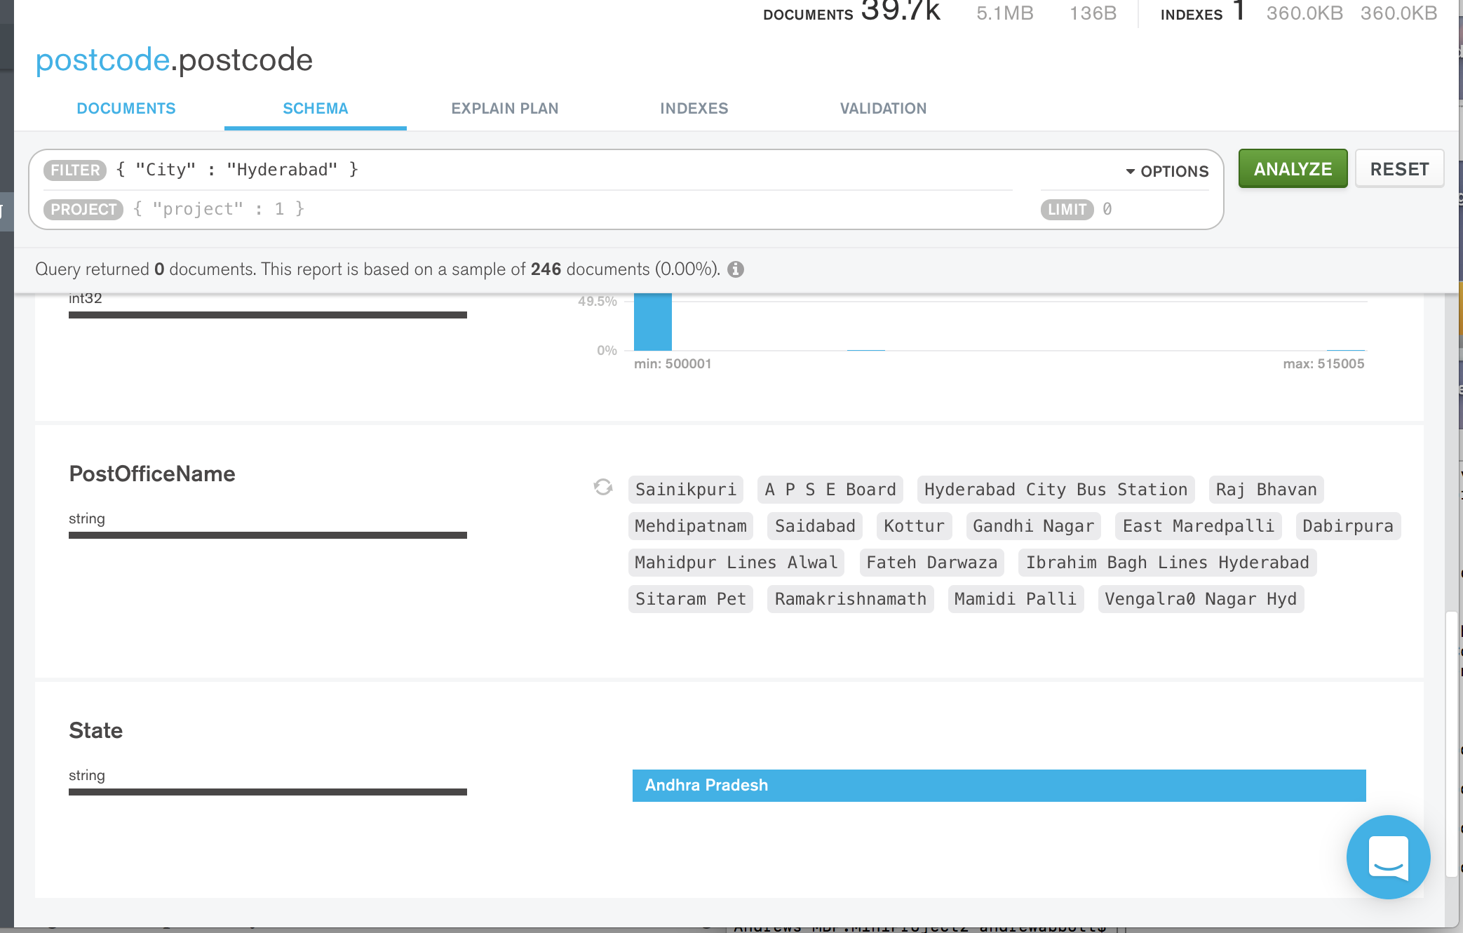

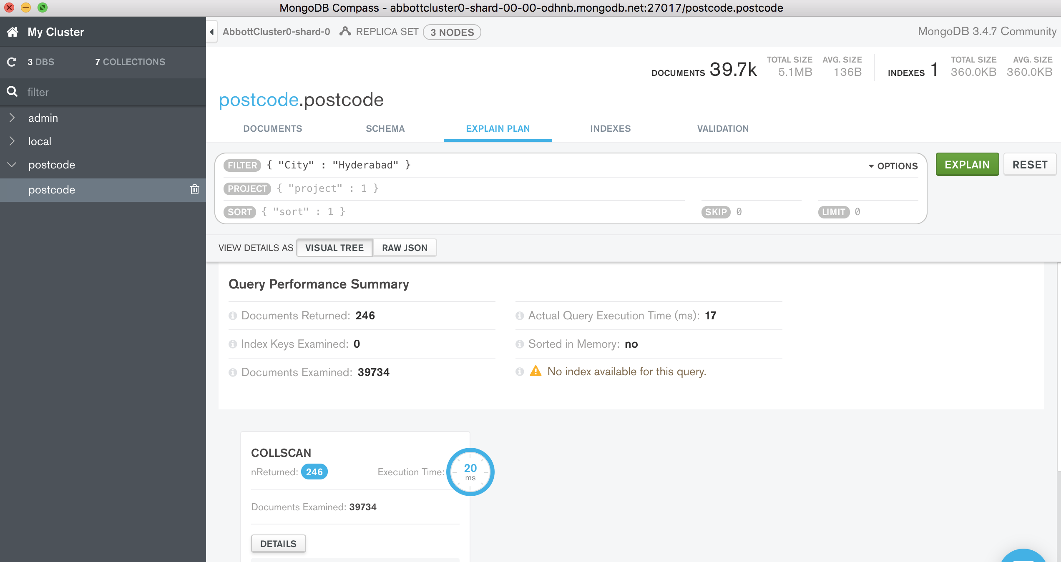

For all sections of this project I had no collaborators and used only the guides and prompts on the MongoDB site.